EcoBloc4R – Plastic EcoBloc with Roller Support – Is designed specifically for use on rooftop without adhesive, roof penetrations, flashings or damage to roofing system. Designed to support shifting pipe lines sizes up to ∅4" or ∅8”. System consists of either a 4” or 8” SRB plastic roller unit bolted directly to an **EcoBloc** with 3/8” X 1-1/2” Lag Bolts with 3/8” washers.

**Materials** 

**EcoBloc:** Manufactured from Recycled Plastic, extruded.

Density 57-60 lbs/ft³. Compressive strength (psi) 3500.

**LEED:** Minimum 96% comingled post consumer and/or post industrial recycled plastics with UV stability additives.

**Roller:** 4” or 8” SRB Plastic Roller

**Roller Frame:** Angle fitting available in Pre-Galvanized Zinc coated or Hot-Dip Galvanized finishes.

**Hardware:** 3/8” X 1-1/2” Lag Bolts with 3/8” washers; Roller uses 1/2” X 5-1/2” Bolts with 1/2” Nuts available in Pre-Galvanized Zinc coated, Hot-Dip Galvanized or Stainless Steel finishes.

**Accessories:** Protection Pads

**Installation:**

1. Verify that roof surface is smooth and clean to extent needed to receive materials.
2. Review approved final drawings to determine the locations of EcoBloc Supports.
3. Clean surfaces to receive EcoBloc Supports removing any loose gravel and any foreign matter before setting EcoBloc Supports.
4. Accurately locate and align pre-fabricated EcoBloc supports in locations specified as per approved shop drawings or as required herein and by site conditions to limit pipe and/or conduit deflection to L/240, not to exceed 10' (3m) on center. If Isolation pads are required, place under each EcoBloc Support.
5. Should the roofing manufacturer require a separation sheet between the roof and the EcoBloc Support, place a separation sheet or protective pad conforming to the existing roof manufacturer’s system under each EcoBloc Support. Do not adhere to the roof system or to EcoBloc Support.
6. Repeat until all supports supplied are installed in accordance with approved shop drawings.
7. Remove any unused materials and packaging from job site.

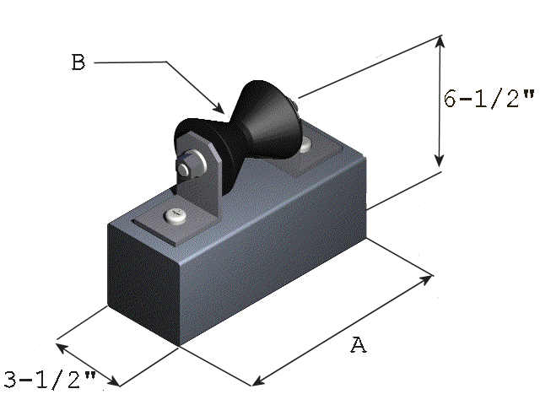

|  |  |  |  |
| --- | --- | --- | --- |
| **Model** | **Dimensions** | | **Weight** |
| **A** | **B** |
| 4EB9R  4EB13R | 9”/22.86cm  13”/33.02cm | 4”/10.20cm  8”/20.32cm | 7 lb/3.18kg  10 lb/4.54kg |

This print/image and design and detail shown hereon is the property of Advanced Support Products, Inc. This print is furnished with the understanding that it is not to be reproduced without permission, and must be returned upon demand. All rights of design and invention are reserved by Advanced Support Products. Patents #5816554 ; #6229497; #6427965; #6448497; #6578827 © 2010

Specification Sheet

EcoBloc4R

**Plastic EcoBloc with Roller**