SS1000E –Equipment Support – Is designed specifically for use on rooftop without adhesive, roof penetrations, flashings or damage to roofing system. Designed to support light-weight HVAC equipment with 6” X 6” galvanized steel support bracket. Height is telescopic to 18”. When equipment requires corner supports, use **SS1000EC** as an alternative. Weight disbursed over 227 sq. in. per support.

**Materials** 

**Support Base:** 17" circular base, injected molded polypropylene, with 227 sq. in. of surface on bottom, designed for weight displacement.

**Base Dimensions:** 3"H X 17" in diameter, designed for weight displacement, with molded insert for square tubing and two threaded rod couplings molded in.

**LEED:** Minimum 40 % post industrial recycled polypropylene with UV inhibitors.

**Frame:** 6”X6” Steel Support Bracket, Hot-Dip Galvanized welded to

1-7/8” X 1-7/8” 12 gauge square tubing supported by 1-5/8” X 1-5/8” 12 gauge square tubing available in Pre-Galvanized Zinc coated or Hot-Dip Galvanized.

**Hardware:** 1/2” X 2-1/2” Bolts; 1/2” Nuts, & Washers available in Pre-Galvanized Zinc coated, Hot-Dip Galvanized or Stainless Steel finishes.

**Accessories:** Protection Pads

This print/image and design and detail shown hereon is the property of Advanced Support Products, Inc. This print is furnished with the understanding that it is not to be reproduced without permission, and must be returned upon demand. All rights of design and invention are reserved by Advanced Support Products. Patents #5816554; #6229497; #6427965; #6448497; #6578827 © 2010

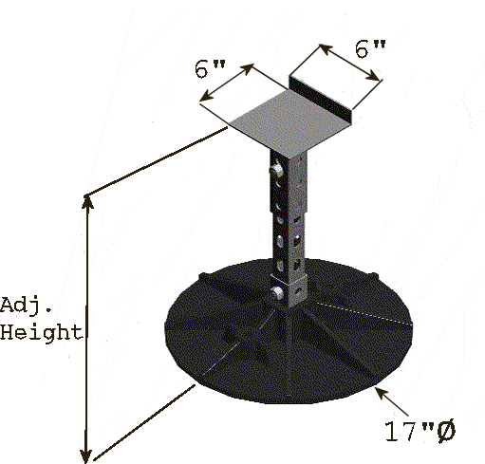

**Installation:**

1. Verify that roof surface is smooth and clean to extent needed to receive materials.
2. Review approved final drawings to determine the locations of supports.
3. Clean surfaces to receive supports removing any loose gravel and any foreign matter before setting support 17” circular bases.
4. Accurately locate where equipment will be placed according to project drawings. Insert frame structure into center cavity of 17” circular base as indicated by above drawing. Place equipment on 6” steel support bracket aligning the steel brackets along the side of the equipment. No Isolation pads are required under the 17" circular bases.
5. Should the roofing manufacturer require a separation sheet between the roof and the support system, place a separation sheet or protective pad conforming to the existing roof manufacturer’s system under 17" circular bases. Do not adhere to the roof system or 17" circular bases.
6. Repeat until all supports supplied are installed in accordance with approved shop drawings.
7. Remove any unused materials and packaging from job site.

Specification Sheet

SS1000E

**Equipment Support**