SS2000D – Duct/Pipe Support – Is designed specifically for use on rooftop without adhesive, roof penetrations, flashings or damage to roofing system. Utilized to support HVAC duct with adjustable height. Use in connection with strut clamps or roller accessories for pipe support. Weight disbursed over 454 sq. in. per support. Custom heights are available.

**Materials** 

**Support Base:** 17" circular base, injected molded polypropylene, with 227 sq. in. of surface on bottom, designed for weight displacement.

**Base Dimensions:** 3"H X 17" in diameter, designed for weight displacement, with molded insert for square tubing and two threaded rod couplings molded in.

**LEED:** Minimum 40 % post industrial recycled polypropylene with UV inhibitors.

**Frame:** 1-5/8” X 1-5/8” 12 ga. channel (ASTM A653) available in Pre-Galvanized Zinc coated, Hot-Dip Galvanized or Stainless Steel finishes.

**Hardware:** Corner Brackets; 1/2” X 2-1/2” Bolts; 1/2” Nuts available in Pre-Galvanized Zinc coated, Hot-Dip Galvanized or Stainless Steel finishes.

**Accessories:** Strut Clamps; Rollers; Protection Pads

**Installation:**

1. Verify that roof surface is smooth and clean to extent needed to receive materials.
2. Review approved final drawings to determine the locations of supports.
3. Clean surfaces to receive supports removing any loose gravel and any foreign matter before setting support 17” circular bases.
4. Accurately locate and align pre-fabricated pipe supports in locations specified as per approved shop drawings or as required herein and by site conditions to limit pipe and/or conduit deflection to L/240, not to exceed 10' (3m) on center. No Isolation pads are required under the 17" circular bases.
5. Should the roofing manufacturer require a separation sheet between the roof and the support system, place a separation sheet or protective pad conforming to the existing roof manufacturer’s system under 17" circular bases. Do not adhere to the roof system or 17" circular bases.
6. Insert frame structures into 17" circular bases as indicated in above drawing.
7. Adjust height of each strut or channel and roller to its required height and tighten with nut, but do not over-tighten. Check each support for equal weight disbursement. Correct if necessary.
8. Repeat until all supports supplied are installed in accordance with approved shop drawings.
9. Remove any unused materials and packaging from job site.

This print/image and design and detail shown hereon is the property of Advanced Support Products, Inc. This print is furnished with the understanding that it is not to be reproduced without permission, and must be returned upon demand. All rights of design and invention are reserved by Advanced Support Products. Patents #5816554; #6229497; #6427965; #6448497; #6578827 © 2010

|  |  |  |  |
| --- | --- | --- | --- |
| **Model** | **Dimensions** | | **Weight** |
| **A** | **B** |
| SS2000D/18  SS2000D/24  SS2000D/36  SS2000D/48 | 36”/91.4cm  36”/91.4cm  36”/91.4cm  36”/91.4cm | 18”/45.7cm  24”/61.0cm  36”/91.4cm  48”/121.9cm | 24 lb/10.88 kg  26 lb/11.79 kg  28 lb/12.70 kg  30 lb/13.61 kg |

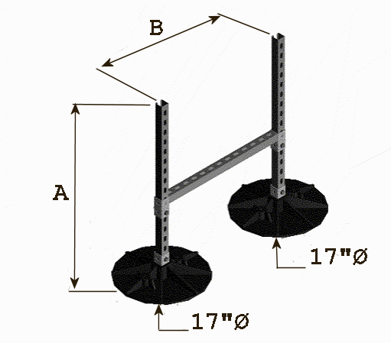

Specification Sheet

SS2000D

**Adjustable Duct/Pipe Support**